Task 0108913 – TFL FTP Solution

TMA Inspection files need to be transferred from the FTP site down to the database for upload into exor.

This document covers the first part of the solution – FTP site to database server.

Files shipped –

* **0108913_install.sql** – Installation file - $3.0
  + **Create_job.sql** – Create Job script - $3.0
  + **Nm3jobs.pkh** – Job scheduling wrapper package - $3.0
  + **Nm3jobs.pkw** – Job scheduling wrapper package - $3.0
  + **X_tfl_tma_ftp.pkh** – Job scheduling wrapper package - $3.0
  + **X_tfl_tma_ftp.pkw** – Job scheduling wrapper package - $3.0

By default, the process will run at 12:00pm (midday) everyday of the week, moving the files from the FTP site (specified during installation) and moved to the database directory TMA_INSP_IMPORT_DIRECTORY on the server (as used by TMA).

There are details later in this document for customisation.

Installation of patch

Unzip the 0108913.zip file into a folder, such as C:\0108913.

Start SQLPLUS, using this folder as the “Start In” and type the following, and press Return -

* + **Start 0108913_install.sql**

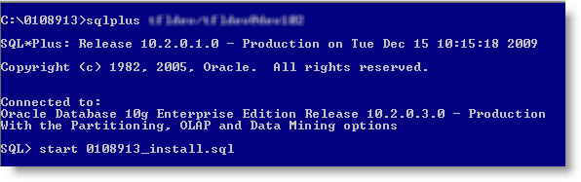

The installation process will run, and you will be prompted for the following information –

* **ENTER THE IP ADDRESS OF THE FTP SITE :**
  + The IP Address of the FTP site you wish to move files from (i.e. 192.168.xx.xx). This may work with a hostname, however the hostname needs to be resolvable from the database server.
* **ENTER THE INCOMING FOLDER ON THE FTP SITE :**
  + The folder on the FTP site which holds the TMA Inspection files (i.e. /incoming/tma/insp).
* **ENTER THE FTP USERNAME :**
  + The username of the FTP site.
* **ENTER THE FTP PASSWORD :**
  + The password of the FTP site.
* **ENTER THE FTP PORT :**
  + The default port for FTP connections is usually 21.

Once the information has been entered, please check the logfile (0108913_install.sql) for any errors.

Scheduled Job

Once the installation script has run and the log file as been checked, make sure the Job as been created –

SELECT owner, job_name, job_creator, job_action, start_date, repeat_interval

, last_start_date, last_run_duration, next_run_date

FROM all_scheduler_jobs

WHERE job_name = 'TMA_INSP_FTP';

This will show the job (TMA_INSP_FTP) which will execute the packaged procedure () to perform the moving of the files from FTP Site to Database server.





It will show the

* OWNER - i.e. the Highways owner
* JOB_NAME – TMA_INSP_FTP
* JOB_ACTION – The PL/SQL packaged procedure being called.
* START_DATE – Date the job was created
* REPEAT_INTERVAL – Shipped as 12 midday
* LAST_START_DATE – Will be NULL until it runs at least once.
* LAST_RUN_DATE – Will be NULL until it runs at least once.
* NEXT_RUN_DATE – Date/Time it’s due to run.

Once the Job has executed, you can check to ensure it has run -

SELECT owner, job_name, job_creator, job_action, start_date, repeat_interval

, last_start_date, last_run_duration, next_run_date

FROM all_scheduler_jobs

WHERE job_name = 'TMA_INSP_FTP';





Log Table

After the PL/SQL has been executed, you can check the results by querying the table XTFL_FTP_LOG –

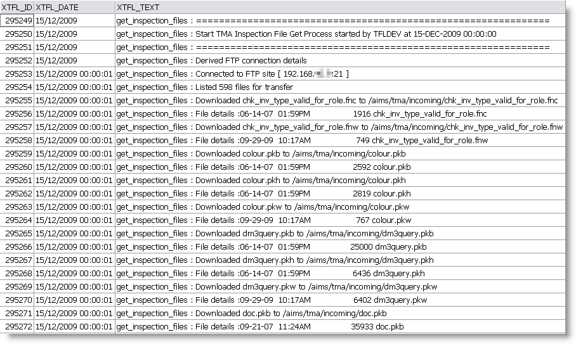

This will provide a log of all files that have been copied and deleted from the FTP site.

The data will be prefixed with “get_inspection_files : “.

Customisation

If the Scheduled Job needs amending, then use the create_job.sql script to drop and recreate it, with optional parameters –

You can specify the FTP Type if you create a different set of metadata (from X_TFL_FTP_DIRS table). This is defaulted to ‘TMAI’ as created in the installation scripts.

Oracle Directory is defaulted to TMA_INSP_IMPORT_DIRECTORY – this can be specified differently if required.

Delete files is defaulted to TRUE – so the files will be cleared down from the FTP site after being copied to the Database Server.

x_tfl_tma_ftp.get_inspection_files ( pi_ftp_type

, pi_orcl_directory

, pi_delete_files );

The Job interval is specified in the create_job.sql installation script – you can change this –

l_int VARCHAR2(1000) := 'freq=daily; byhour=12; byminute=0; bysecond=0;';

At the moment it’d set to 12:00 midday.

6pm would be

l_int VARCHAR2(1000) := 'freq=daily; byhour=18; byminute=0; bysecond=0;';

6am would be etc

l_int VARCHAR2(1000) := 'freq=daily; byhour=6; byminute=0; bysecond=0;';

Example of create_job.sql changed to run at 6pm, use a different FTP Type, a directory called TMA_INSP and to NOT delete the files –

DECLARE

ex_no_exists EXCEPTION;

PRAGMA EXCEPTION_INIT (ex_no_exists,-27475);

l_int VARCHAR2(1000) := 'freq=daily; byhour=18; byminute=0; bysecond=0;';

BEGIN

--

BEGIN

nm3jobs.drop_job ( pi_job_name => 'TMA_INSP_FTP'

, pi_force => TRUE );

EXCEPTION

WHEN ex_no_exists THEN NULL;

END;

--

nm3jobs.create_job

( pi_job_name => 'TMA_INSP_FTP'

, pi_job_action => 'BEGIN x_tfl_tma_ftp.get_inspection_files (‘’TFL_NEW_INSP’’,’’TMA_INSP’’,FALSE ); END;'

, pi_comments => 'Created by nm3jobs at '||to_char(SYSDATE,'DD-MON-YYYY HH24:MI:SS')

, pi_repeat_interval => l_int);

END;

/